2026-10-04 · · ~ 40 Mins
Tool: <Gemini/Notebook>
What I asked for: I am making a AS-IS and TO-BE scenarios list and need help in building it if possible. I can provide the issues list and we can build from there.
What came back: 11 Candidates, 11 Rejected, Mainly confirming of what I asked and was ready for input on issues list from Discord
What I changed: Supplied issues list from discord for context on the types of issues found within the group
Verified against: Issues List (Discord)
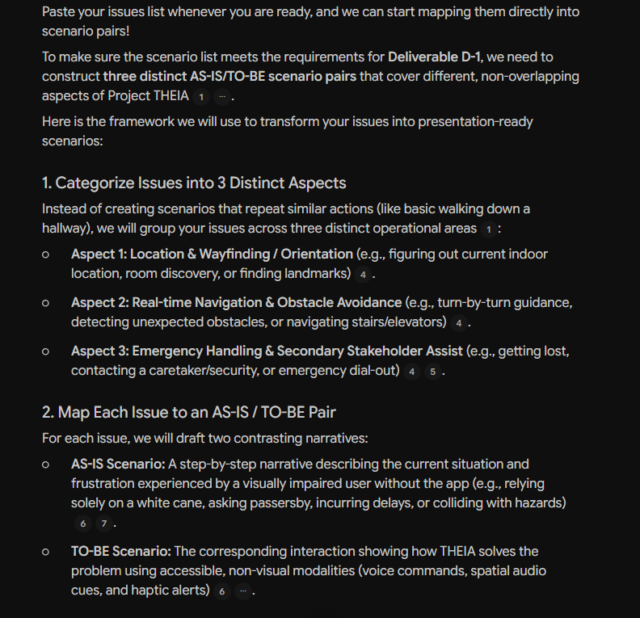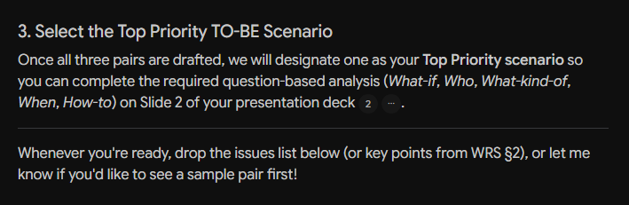
2026-10-04-.png
Tool: <Gemini/Notebook>
What I asked for: Copied and Pasted the issues list from discord
What came back: 4 Candidates, 2 accepted, 2 rejected, gave ideas and potential context to build from for AS-IS and TO-BE scenarios
What I changed: Read through, and choose two of the 3 scenarios that best fits the project based on the combination of issues mentions from the issues list
Verified against: Issues List (Discord)
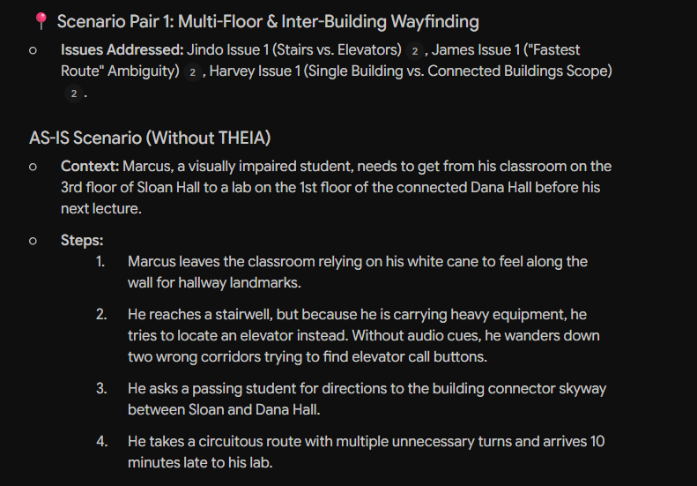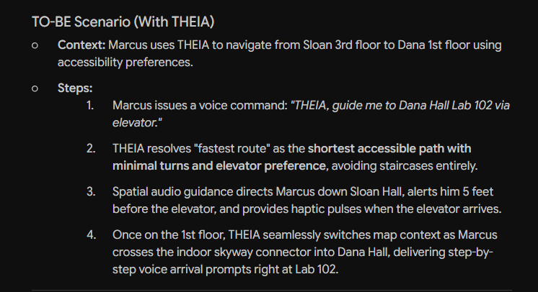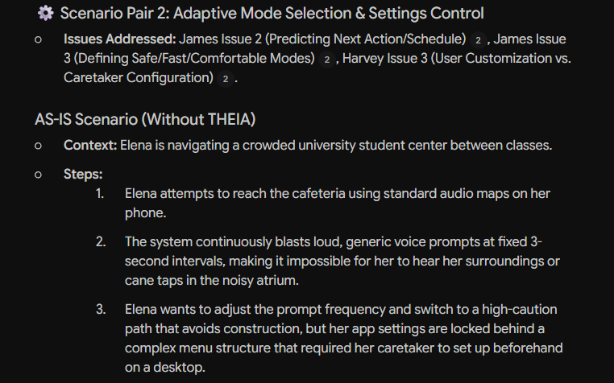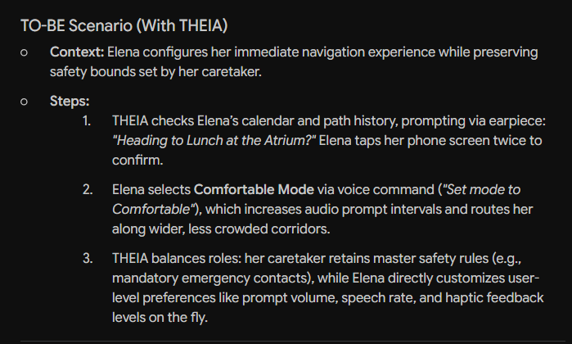
2026-10-04-.png
2026-10-04 · · ~ 3 Mins
Tool: <Gemini/Notebook>
What I asked for: List out the strengths between all four scenarios to see what could lead to them being top priority
What came back: 3 Candidates, 1 Accepted, 2 Rejected, Mainly confirming of what I asked and was ready for input on issues list from Discord
What I changed: Went over the list of each scenarios strengths and decided on which would be the top priority
Verified against: Issues List (Discord)
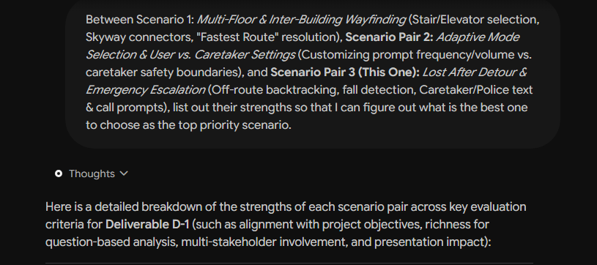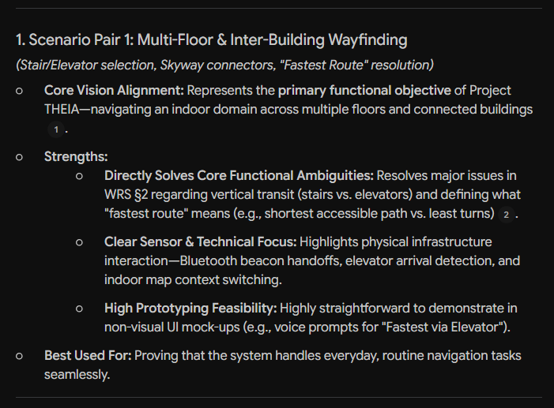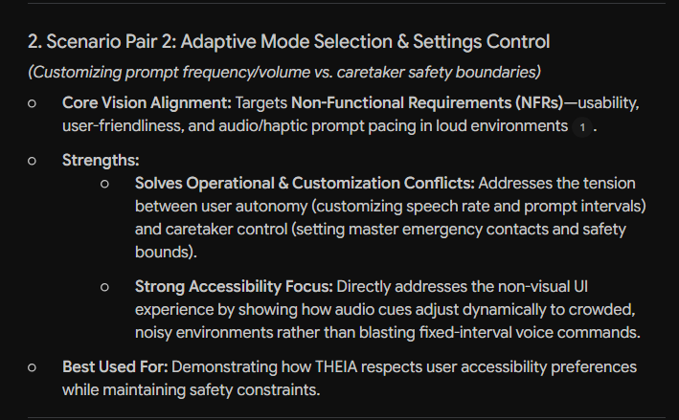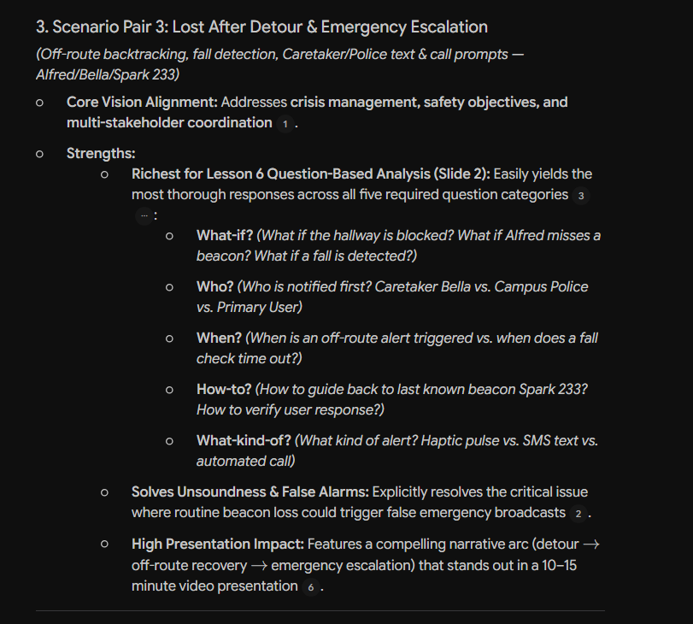
2026-10-04-.png

